Problem 1:
Q-Learning using Image Frames to Learn a Game Policy
Implementation Understanding:
The code so that during training and during play, an illegal move is not allowed. Updated select_model_action() in train.py
def select_model_action(
device: torch.device, model: Network, state: torch.tensor, eps: float
):
sample = random.random()

# Get valid moves (empty cells)
state_np = state.cpu().numpy().reshape(3,3,3)
valid_moves = (state_np.argmax(axis=2).reshape(-1) == 0)
valid_indices = np.where(valid_moves)[0]

if sample > eps:
with torch.no_grad():
q_values = model(state).cpu().numpy().reshape(-1)

# Mask invalid moves
q_values[~valid_moves] = -1e9

action = np.argmax(q_values)
return torch.tensor([[action]], device=device, dtype=torch.long), False
else:
action = random.choice(valid_indices)
return torch.tensor([[action]], device=device, dtype=torch.long), True
Modify select_dummy_action(). So that random player only picks empty cells
def select_dummy_action(state: np.array) -> int:
state = state.reshape(3, 3, 3)

open_spots = state[:, :, 0].reshape(-1)
valid_indices = np.where(open_spots == 1)[0]

return np.random.choice(valid_indices)

Output:
Output when an illegal move is allowed
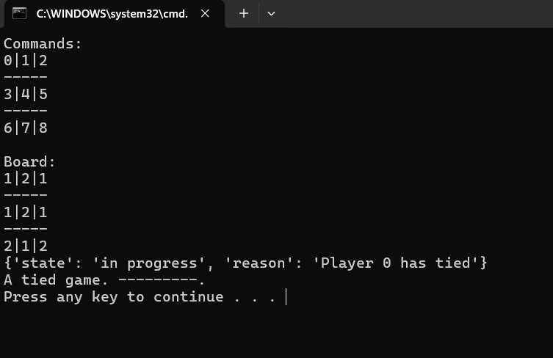

Output when an illegal move is not allowed
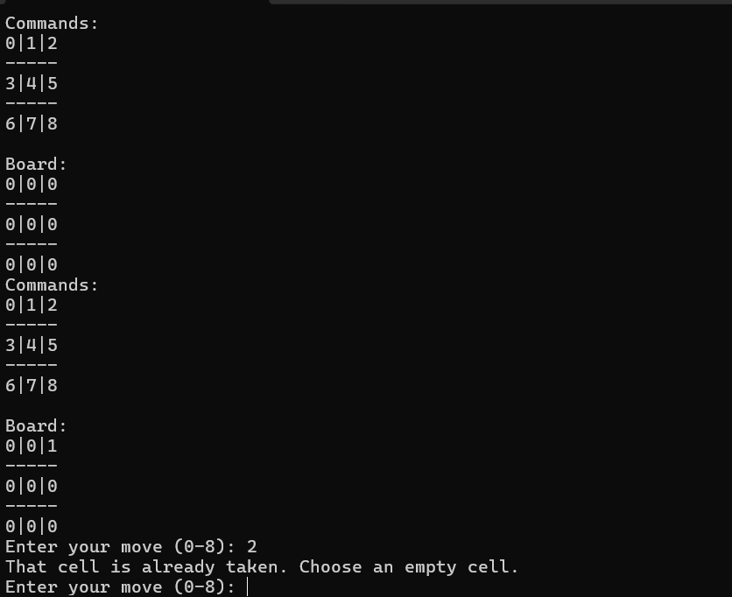
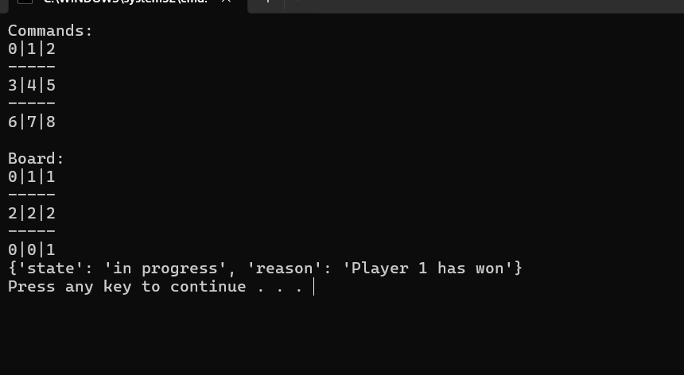

Training:
model = load_model('checkpoint/tictactoe_policy_model.pt',device) with illegal moves

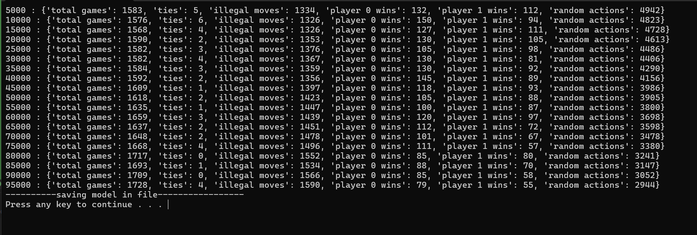

model = load_model('checkpoint/tictactoe_policy_model_without_illegal_moves.pt
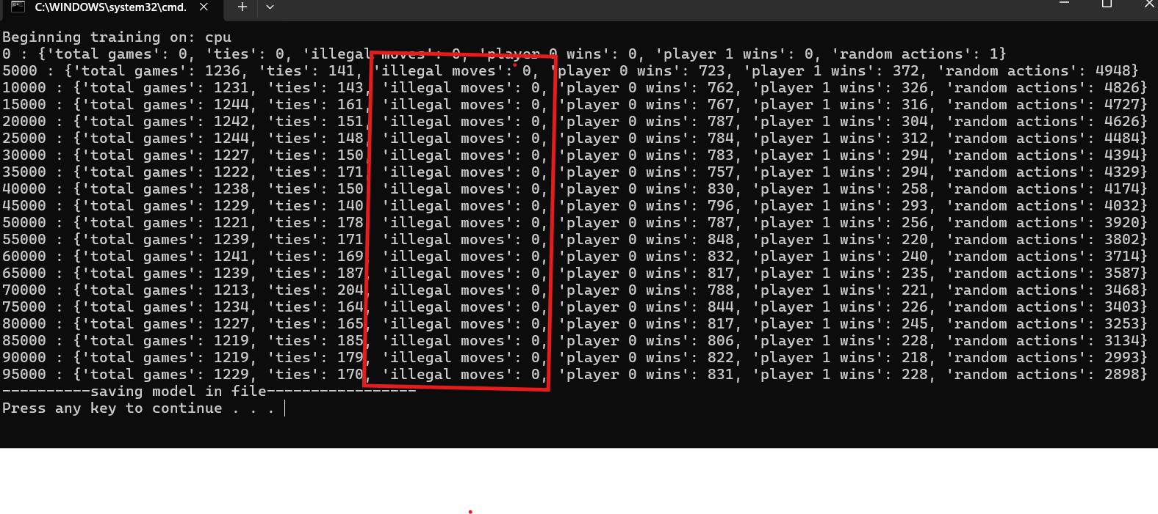
Discussion
The original implementation allowed illegal actions by selecting already occupied cells. I modified the action selection logic so that both exploration and exploitation only choose from valid empty cells. During training, invalid actions are masked before selecting the maximum Q-value, and random exploration samples only from available cells. During play, the same masking is used for the trained agent, and the human input is validated to reject occupied or out-of-range cells. As a result, illegal moves are prevented during both training and gameplay.

Problem 2:
Implementation Understanding:
The CartPole problem is implemented using a Deep Q-Network (DQN) with two networks: a policy network for action selection and a target network for stable Q-value estimation. The agent interacts with the environment, stores experiences in replay memory, and learns by sampling mini-batches to break correlation between consecutive states. An ε-greedy strategy is used for exploration and gradually shifts toward exploitation. The target network is softly updated from the policy network to improve stability. The model learns to maximize cumulative reward by keeping the pole balanced, reflected by increasing episode durations over time.
Output:
With 400 epochs
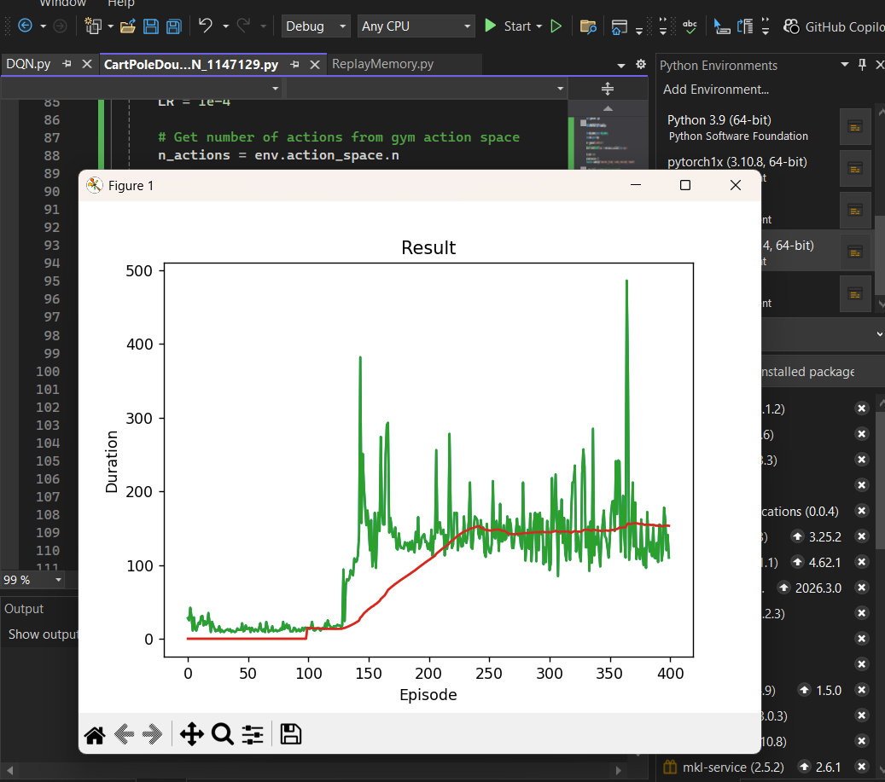
Result: Not balancing the cartpole
With Epoch 700
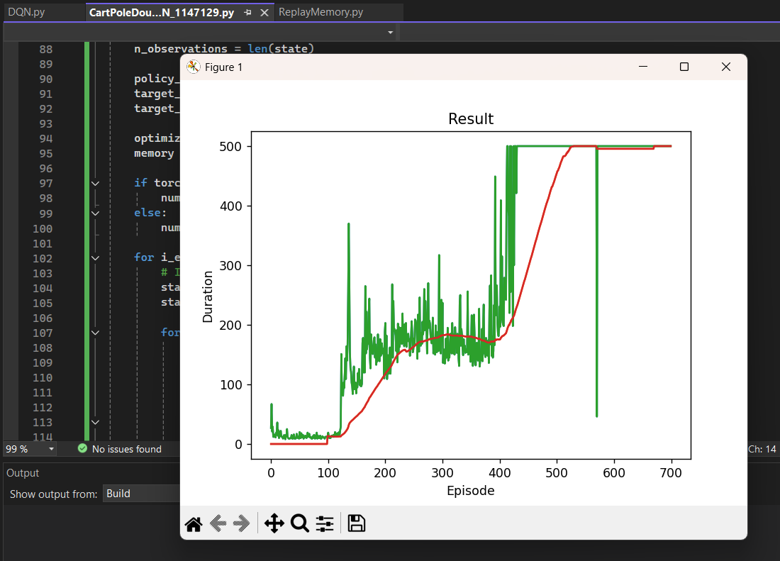

Discussion:
In Part B, the CartPole problem was solved using a DQN-based approach with a separate target network, which helps stabilize learning by reducing the strong correlation between predicted Q-values and target Q-values. The agent learns by interacting with the CartPole-v1 environment, storing experiences in replay memory, and updating the policy network from randomly sampled mini-batches. The target network is updated gradually using soft updates, which improves training stability. During training, the episode duration increases over time, showing that the agent is learning how to keep the pole balanced for longer periods. After sufficient training, the model is able to choose actions that keep the pole upright and the cart centered for much longer than at the beginning, demonstrating successful reinforcement learning performance.
